**VISVESVARAYA TECHNOLOGICAL UNIVERSITY**

**“JnanaSangama”, Belgaum -590014, Karnataka.**



**LAB REPORT**

**on**

**Object-Oriented Modelling and Design**

**20CS6PCOMD**

***Submitted by***

**SOHAN R KUMAR (1BM19CS159)**

***in partial fulfillment for the award of the degree of***

**BACHELOR OF ENGINEERING**

***in***

**COMPUTER SCIENCE AND ENGINEERING**



**B.M.S. COLLEGE OF ENGINEERING**

**(Autonomous Institution under VTU)**

**BENGALURU-560019**

**May-2022 to July-2022**

**B. M. S. College of Engineering,**

**Bull Temple Road, Bangalore 560019**

(Affiliated To Visvesvaraya Technological University, Belgaum)

**Department of Computer Science and Engineering**



**CERTIFICATE**

This is to certify that the Lab work entitled “Object-Oriented Analysis and Design(16CS6DCOOM) Lab Record” was carried out by **SOHAN R KUMAR (1BM19CS159),** who is a bona fide student of **B. M. S. College of Engineering.** It is in partial fulfillment for the award of **Bachelor of Engineering in Computer Science and Engineering** of the Visvesvaraya Technological University, Belgaum during the year 2022. The Lab report has been approved as it satisfies the academic requirements in respect of Object-Oriented Analysis and Design-(16CS6DCOOM)**)** work prescribed for the said degree.

Name of the Lab-In charge               **Dr. SHYAMALA**

Designation Assistant Professor

Department of CSE Department of CSE

BMSCE, Bengaluru BMSCE, Bengaluru

`

**Index Sheet**

|  |  |  |
| --- | --- | --- |
| **Sl. No.** | **Experiment Title** | **Page No.** |
| **1.** | **College Information System** | **4** |
| **2.** | **Hostel Management System** | **7** |
| **3.** | **Stock Maintenance System** | **10** |
| **4.** | **Coffee Vending Machine** | **13** |
| **5.** | **Online Shopping System** | **17** |
| **6.** | **Railway Reservation System** | **20** |
| **7.** | **Graphics Editor** | **23** |

**Course Outcome**

|  |  |
| --- | --- |
| CO1 | Ability to apply the knowledge of class, State & Interaction Modelling using Unified Modeling Language to solve a given problem. |
| CO2 | Ability to analyze a System for a given requirement using Unified Modeling language. |
| CO3 | Ability to design a given system using high level strategy. |
| CO4 | Ability to conduct practical experiment to solve a given problem using Unified Modeling language. |

## **1. COLLEGE INFORMATION SYSTEM**

### 1.1 Problem statement

The College Information System is a system that maintains student,staff and department information . It maintains the courses taught by teachers and students enrolled in them. Admission records of student and Examination details and other important information related to college management is maintained.

### 1.2 Software Requirement Specification

* College information system has admin who manages the staff ,student and department.
* Admin can view and modify the student’s records like student’s profile, attendance, fee, results, and details of teachers and other employees in college, their personal information and their attendance for their salaries.
* In this system, user authentication will be done by login by user name and password and classified by user type.
* Staff in college teach more than one course to many students and the staff who are teachers conduct examinations for students of the college
* The students of the college register themselves in the department and for the courses they are interested in and join the college by taking admission and following all the admission procedures.
* There are different types of examination conducted by the college for the students. Internals and semester end examination are two of them.
* Every course has a name and its unique name. Every course has different subjects and every subject has its own unique name.
* Department will provide the details about departments within a college with their name and every department have its Department name.

1

### 1.3 Class Diagram

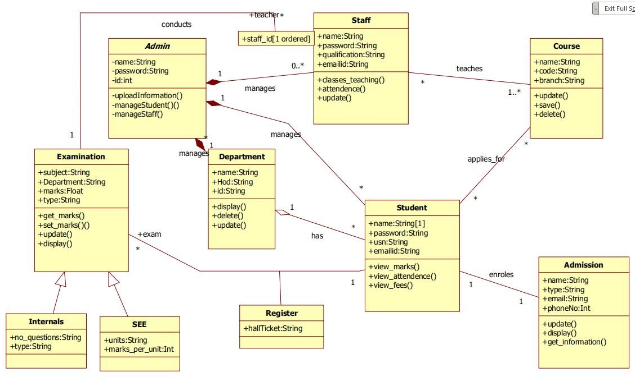

Fig 1.1

Admin can view and modify the student’s records, teachers and department details.The students of the college register themselves in the department and examination and for the courses they are interested in and join the college by taking admission and following all the admission procedures.College conducts Internals and semester end examination for students.

**1.4**

**State**

**Diagram**

**1.4.1**

**Simple**

**State**

**Diagram**

**1.4.2**

**Advanced**

**State**

**Diagram**

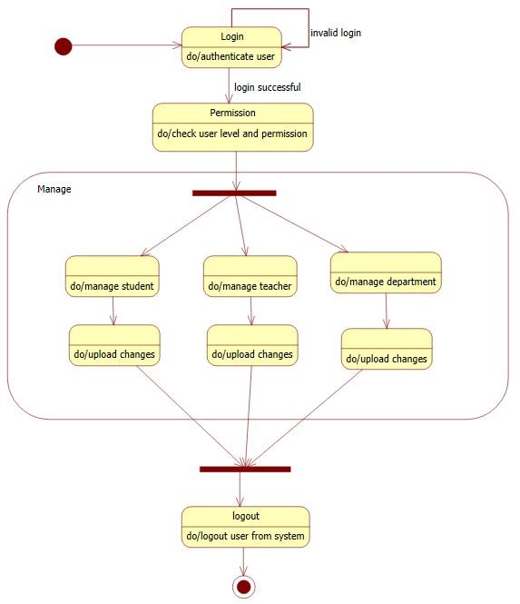

Fig.

1.2

Fig.

1.3

The

above

state

diagram

describes

the

states

the

admin

goes

though

in

uploading

information

of

student,staff

and

department.

The

admin

first

needs

to

login

which

then

leads

to

the

validate

state,where

the

login

id

and

password

are

validated.

If

invalid

it

then

goes

back

to

the

login

state

or

goes

to

the

get

information

state.

Upon

receiving

the

correct

information

it

goes

to

the

upload

state

and

then

to

commit

state

to

save

all

changes.

The

admin

first

needs

to

login

and

be

cleared

of

their

permissions.

The

admin

can

then

manage

information

related

to

the

student,teacher,or

department.After

necessary

changes

the

admin

can

update

the

information

and

logout

from

the

system.

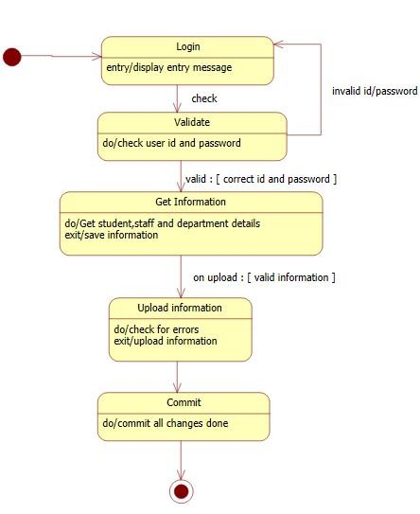

## **2. HOSTEL MANAGEMENT SYSTEM**

### 2.1 Problem statement

The hostel management system is to provide college students accommodation to the university hostel more efficiently. This project also keeps details of the hostelers and applied students. It is headed by Warden. He will be the administrator.This document is intended to minimize human works and make hostel allocation an easier job for students and hostel authorities by providing online application for hostel.

### 2.2 Software Requirement Specification

* Hostel management system has admin who manages the hostel,allot-es and payment methods.The admin will allocate a room to student according to the section or class. The admin will also keep track of the payment made by the student/allot-es .
* As the student’s course is over they will vacate their rooms. So it is required for the administrator to remove their records from the database tables.
* The allot-es makes payment according to the bill generated which have the attributes bill number,type and date.
* The details of the students staying in the hostels like name, place, address, contact details is maintained in the database.
* The hostel is categorized into two types I.e boys and girls hostel.Each hostel type has different costs ,warden and name.
* A hostel is made up of mess and rooms.A mess account will also generate. This account having the mess status of the whole month. On the base of this account monthly charges of mess of a student will be defined.
* The hostel management system will allow renewing the student’s registration every year.the rooms of hostel are composed of table and beds,where a count of the same is maintained and the allot-es can use them as they wish.

### 2.3 Class Diagram

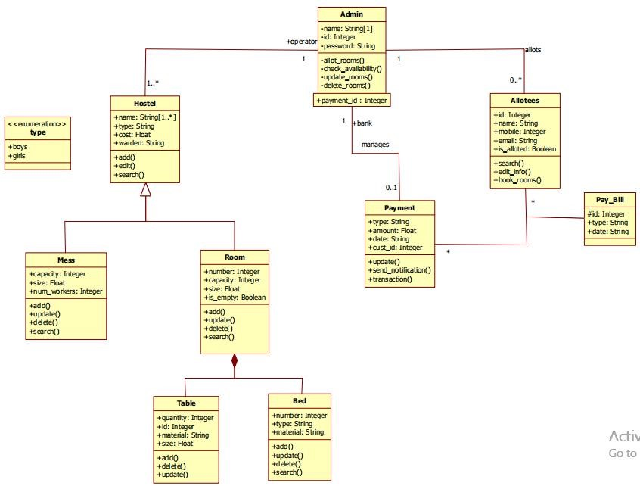Fig 2.1

Hostel management system has admin who manages the hostel,allot-es and payment methods.The allot-es makes payment according to the bill generated which have the attributes bill number,type and date.The hostel is categorized into two types I.e boys and girls hostel.A hostel is made up of mess and rooms.A mess account will also generate. This account having the mess status of the whole month.

**2.4**

**State**

**Diagrams**

**2.4.1**

**Simple**

**State**

**Diagram**

**2.4.2**

**Advanced**

**State**

**Diagram**

Fig.

2.2

The

above

state

diagram

gives

the

movement

of

states

in

allotting

a

room

to

a

student.

The

admin

allots

rooms

for

students.

The

admin

first

login

s

to

the

database

,which

displays

a

set

of

options.the

admin

then

chooses

to

allot

rooms

and

finds

the

availability

for

rooms.

If

rooms

are

available

then

the

admin

allots

room

to

the

student

and

when

successful

the

student

makes

the

payment.

If

no

rooms

are

available,a

message

is

displayed

and

control

goes

back

to

the

display

state.

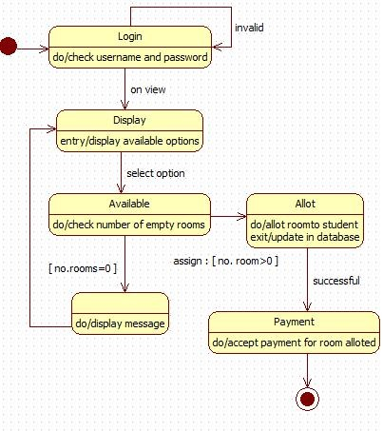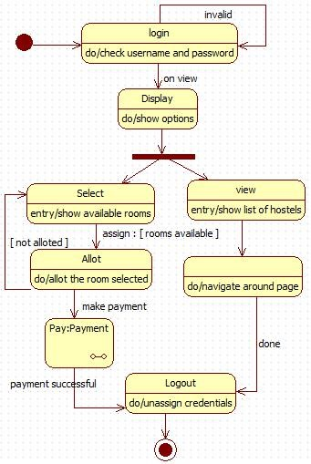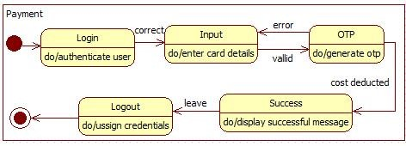

Fig

2.2

Fig

2.3

## **3. STOCK MAINTENANCE SYSTEM**

### 3.1 Problem statement

The stock maintenance system is basically for the customers who access the information about the stock and retrieves the information.The stock maintenance system is to replace the existing maintenance system which is in efficient. The new stock maintenance system will allow the employee to record information of the products available in the store .The vendor deals with the information about the details of the suppliers giving product to the organization.

### 3.2 Software Requirement Specification

* The customer can purchase one or more product on any day,which will have a code price and quantity.
* The customer will need to pay the bill for the products he or she has purchased.the bill number,type description and customer who is paying the bill is maintained.
* The stock of the products is maintained separately,The stock deals with information about the details of the product that the concern handling.
* Stock consist of details such as the name of the product, id generated, quantity, cost, etc. This information is retrieved during the sales and purchase of a product.
* The vendor deals with the information about the details of the suppliers giving product to the organization.
* Vendor consist of details such as vendor name, address, email id, sales tax number etc. This information is retrieved when a Purchase is done
* The products are displayed in stores across the city or world. All the information regarding the store such as store id,name,address and type are used to locate any product.The stores can be of many types.Some of them are departmental stores,super markets and ware houses where the products are kept for display.

### 3.3 Class Diagram

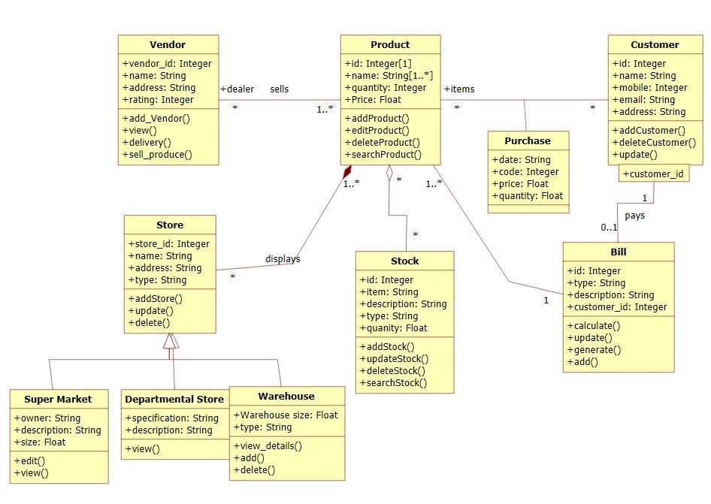

Fig

3.1

The products are displayed in stores across the city or world. All the information regarding the store are used to locate any product.The stores can be of many types.Some of them are departmental stores,super markets and ware houses where the products are kept for display.The vendor deals with the information about the details of the suppliers giving product to the organization.The stock of the products is maintained separately.The stock deals with information about the details of the product that the concern handling.

**3.4**

**State**

**Diagrams**

**3.4.1**

**Simple**

**State**

**Diagram**

**3.4.2**

**Advanced**

**State**

**Diagram**

The

state

diagram

above

gives

us

the

states

involved

in

purchasing

an

product

and

placing

the

order

for

the

same.

There

is

first

an

inventory

check

,where

is

stock

of

products

is

noted

and

if

the

stock

is

less

than

minimum

an

order

is

placed

by

first

searching

for

suitable

trader

.

if

a

suitable

trader

is

found

,

the

order

is

placed

and

verified

by

the

accountant.

After

the

accountant

has

verified

a

payment

is

made

for

the

products

purchased.

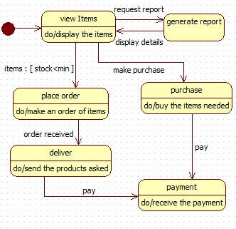

Fig

3.3

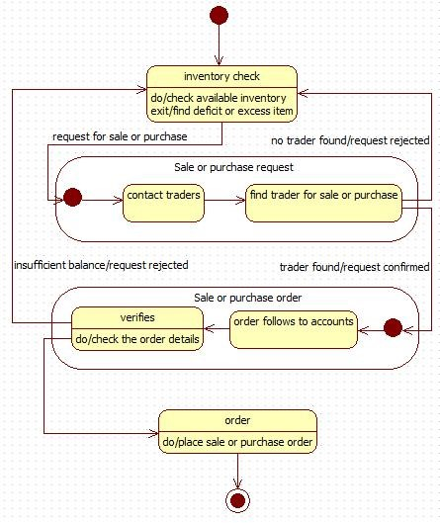

Fig

3.2

## **4. COFFEE VENDING MACHINE**

### 4.1 Problem statement

The coffee vending machine is basically for the customers to buy coffee by themselves without any third person being involved. A coffee vending machine sells different types of coffee such as cappuccino,black coffee,cold coffee and latte. Each type of coffee has a price and a name. A customer can buy their choice of coffee by selecting the button of their coffee and paying for the same through the coin box.

### 4.2 Software Requirement Specification

* The vending machine must have money box, coin slot, display screen and products i.e coffee for the machine to be used.
* The user on selecting a coffee ,the coffee machine must be able to dispense the selected coffee to the user.
* The user shall get empty cup placed right below the filter.The user shall be able to choose his preferred beverage from the list of options(buttons).
* There must be buttons(start,pause,stop,coffee,tea,milk) for user to interact with the system.
* The user shall be able to purchase one kind of available drink at a time and get back the exact changes if he has put extra money. The user shall be able to quit the dispense of any beverage at any time during the dispensing.
* The system(machine) shall check for properly inserted coins.
* The system shall be able to dispense coffee(or selected beverage) after a coin has been inserted.
* The system must accept coins of different amount and the system must compare the item cost with entered coin.
* The system must check the validity of coins.
* The system shall be able to detect the low amount of ingredients and low number of cups and indicate with an indicator(small LED).

### 4.3 Class Diagram

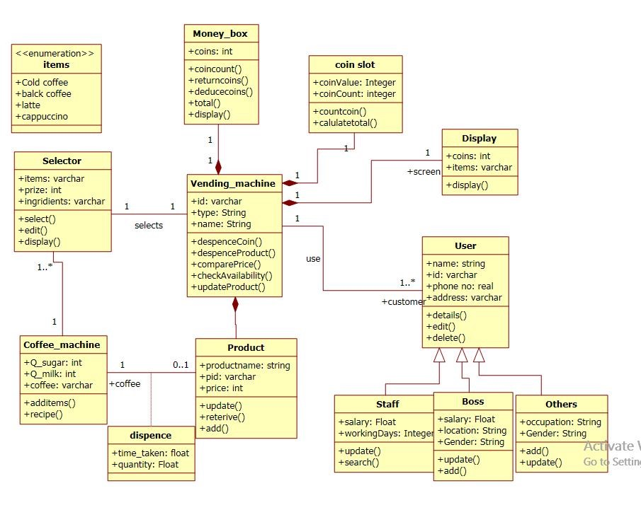

Fig 4.1

The vending machine must have money box, coin slot, display screen and products i.e coffee for the machine to be used.The user on selecting a coffee ,the coffee machine must be able to dispense the selected coffee to the user. The user shall get empty cup placed right below the filter.The user shall be able to choose his preferred beverage from the list of options.There are different types of coffee such as cappuccino,black coffee,cold coffee and latte. Each type of coffee has a price and a name. A customer can buy their choice of coffee by selecting the button of their coffee and paying for the same through the coin box.

**4.4**

**State**

**Diagrams**

**4.4.1**

**Simple**

**State**

**Diagram**

**4.4.2**

**Advanced**

**State**

**Diagram**

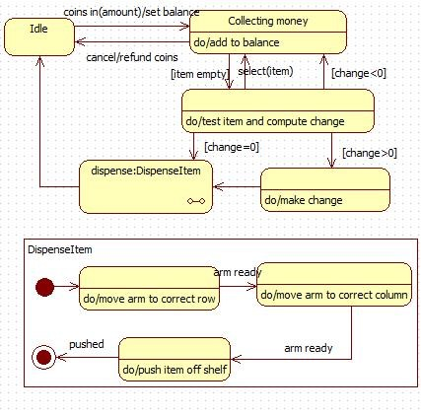

Fig

4.2

Fig

4.3

Initially

the

vending

machine

is

in

the

waiting

state.

The

machine

displays

the

selected

item

selected

by

the

user.

When

the

person

inserts

a

coin

the

machine

adds

the

amount

to

he

cumulative

balance.

After

adding

some

coins,

a

person

can

select

nay

item.

If

item

is

empty

or

balance

is

insufficient,the

machine

waits

for

another

selection.

Otherwise

the

machine

dispense

the

item

and

returns

the

appropriate

change.

The

state

diagram

for

coffee

vending

machine

has

a

submachine

called

dispense

Item

,which

has

the

states

for

dispensing

an

item

from

the

vending

machine.the

arm

of

the

machine

first

moves

to

an

appropriate

row,when

ready,moves

to

an

appropriate

column

and

when

the

arm

is

ready

it

finally

dispences

the

item

from

the

machine.

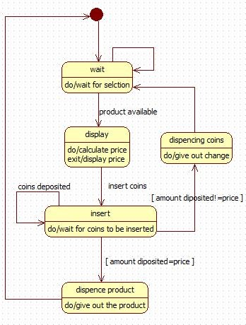

## **5. ONLINE SHOPPING SYSTEM**

### 5.1 Problem statement

The Online Shopping System for all kind of products web application is intended to provide complete solutions for vendors as well as customers through a single get way using the internet. It will enable vendors to setup online shops, customer to browse through the shop and purchase them online without having to visit the shop physically. The administration module will enable a system administrator to approve and reject requests for new shops and maintain various lists of shop category.This system allows the customer’s to maintain their cart for add or remove the product over the internet.

### 5.2 Software Requirement Specification

* The customer must have an account in the online website where he/she can purchase products.
* If customer wants to buy the product then he/she must be registered, unregistered user can’t go to the shopping cart.
* Customer login to the system by entering valid user id and password for the shopping.
* Changes to cart means the customer after login or registration can make order or cancel order of the product from the shopping cart.
* The products sold for customers are sold for various categories like men,women,kids and home products.
* Customers can view all available products ,compare them and make a choice for purchasing the products.
* For customer there are many type of secure billing will be prepaid as debit or credit card, post paid as after shipping, check or bank draft. The security will provide by the third party like Pay-Pal etc.
* After the payment or surf the product the customer will logged out.

### 5.3 Class Diagram

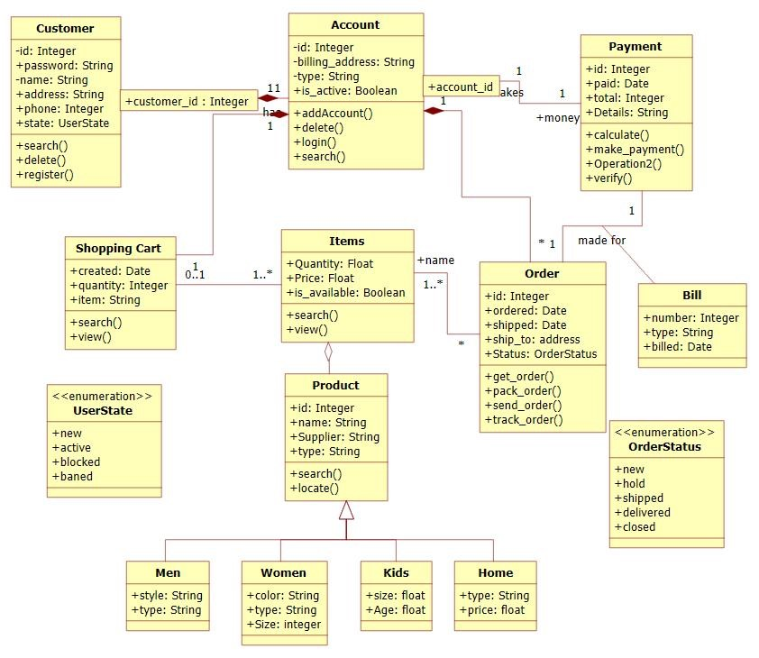

Fig

5.1

The online shopping system has customers who must have an account in the online website where he/she can purchase products.If customer wants to buy the product then he/she must be registered, unregistered user can’t go to the shopping cart.Customer login to the system by entering valid user id and password for the shopping.The products sold for customers are sold for various categories like men,women,kids and home products.After the payment or surf the product the customer will logged out.

**5.4**

**State**

**Diagrams**

**5.4.1**

**Simple**

**State**

**Diagram**

**54.2**

**Advanced**

**State**

**Diagram**

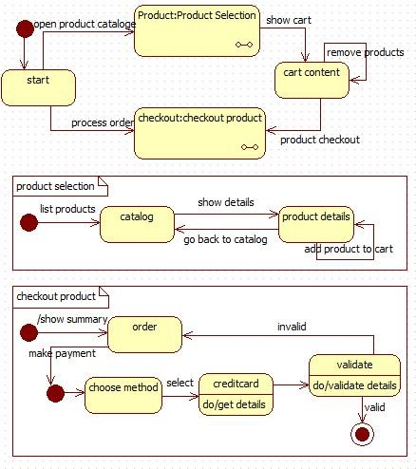

Fig

5.2

Fig

5.3

The

simple

state

chart

diagram

gives

us

states

in

purchasing

a

order

and

paying

for

the

order.

The

customer

is

first

mad

to

register

and

then

login

into

their

account.

Then

the

items

are

displayed,where

they

can

select

their

choice

and

add

them

to

cart

or

reserve

or

order

them.

The

transaction

details

are

displayed.

The

advanced

state

chart

diagram

has

states

explaining

the

product

purchase

and

payment.

It

has

two

sub

machines

i.e

product

selection

and

checkout

product.

Product

selection

allows

us

to

select

products

and

add

them

to

cart.

Checkout

product

has

states

explaining

the

payment

methods

and

validating

the

methods.

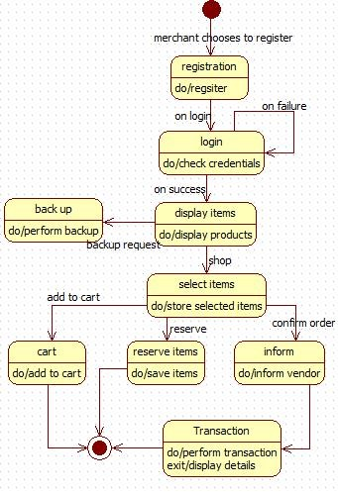

## **6. RAILWAY RESERVATION SYSTEM**

### 6.1 Problem statement

Railway Reservation System is a system used for booking tickets over internet.Any Customer Can book tickets for different trains.Software has to be developed for automating the manual reservation system of railway.The system should be standalone in nature.It should be designed to provide functionalists like booking of tickets in which a user should be able to applied for tickets of any train and of any class.The software takes the current system date and time as the date of issue and calculates the amount to be paid by the user. It also provide the functionality of cancellation of tickets.

### 6.2 Software Requirement Specification

* Each user should have a user id and a password.Record of the users of the system should be kept in the log file. Provision should be made for full backup of the system.
* The customers can view the trains available at any day,the cost and number of tickets available for any train.
* Customer can book a ticket only if the tickets are available.Customer searches for the availability of tickets then if the tickets are available he books the tickets by initially filling details in a form.
* Tickets can be booked in two ways by i-ticket or by e-ticket booking.
* In case of i-ticket booking customer can book the tickets online and the tickets are couriered to Particular customer at their address.But in case of e-ticket booking and canceling tickets are booked and canceled online sitting at the home and customer himself has to take print of the ticket but in both the cases amount for tickets are deducted from customers account.
* For cancellation of ticket the customer has to go at reservation office than fill cancellation form and ask the clerk to cancel the ticket than the refund is transferred to customer account.  After booking ticket the customer has to checkout by paying fare amount to clerk.
* The system displays the details of train of which user enter the name.The information is saved and the corresponding updating take place in the database.

### 6.3 Class Diagram

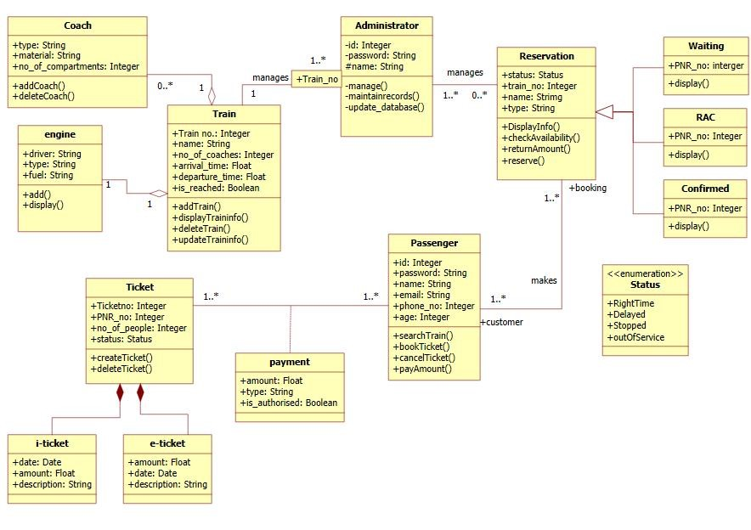

Fig

6.1

The admin manages the trains and reservation related to railway reservation system. There are three types of reservation, I.e RAC,waiting and confirmed.The passengers with a reservation goes to one or the other reservation.A train consists of coaches and engine.A passenger pays for the ticket booked .Tickets can be booked in two ways by i-ticket or by e-ticket booking.

**6.4**

**State**

**Diagrams**

**6.4.1**

**Simple**

**State**

**Diagram**

**6.4.2**

**Advanced**

**State**

**Diagram**

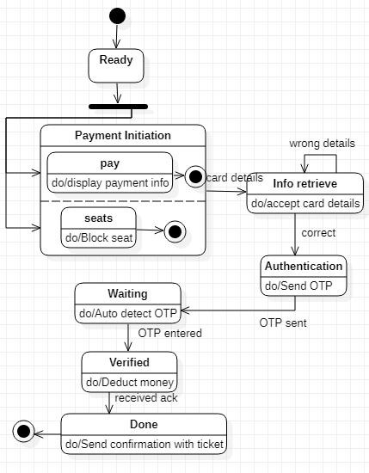

Fig

6.2

Fig

6.3

The

simple

state

diagram

gives

the

states

involved

in

booking

a

train

ticket

and

paying

for

the

same.

The

user

can

see

the

train

details

and

book

a

train

for

a

particular

source

and

destination

.

on

timeout

an

error

message

is

displayed

and

redirected

to

the

main

page.

The

user

can

then

select

a

train

and

make

payment

for

it

The

advanced

state

diagram

has

states

for

paying

the

ticket.from

the

ready

state

the

user

goes

to

payment

initiation

after

which

the

card

details

are

accepted

and

an

OTP

is

sent

to

the

registered

mobile

number.

On

verification

the

money

is

deducted

and

ticket

is

sent

to

the

customer.

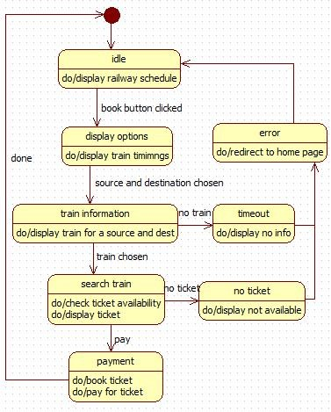

## **7. GRAPHICS EDITOR**

### 7.1 Problem statement

The graphics editor provides an Application Programmer’s Interface that enables a programmer to develop their own graphical model editor for a specific type of model. This API in turn, relies on extending the Eclipse Graphical Editing Framework to provide an environment in which the editor functions, and the programmer can create a graphical editor and palette of shapes in order to modify an underlying model.the graphical editor provides an interface with which the programmer implements said editor for a given underlying model. Such instance of the graphical editor allows a user to drag objects from a specified model into a working graphical diagram.

### 7.2 Software Requirement Specification

* The graphical editor consists of a graphical document editor which can be used to create new document,delete document,update or view the document.
* The graphical document editor consists of many documents,where each document can be saved,opened,printed or create a new one
* A document is made up of many sheets which can have graphics included in them.
* Sheets have multiple number of drawing objects,which can be created, grouped or formatted.
* The programmer must provide implementations of functions that draw objects and their connections, as well as functions that add and remove connections. The latter function will be handled by a specific event listener. Any changes made in real-time to the underlying model will also be updated in the diagram through a separate event listener
* The user can also add and remove connections between these objects as needed using the palette supplied, thus modifying the underlying model.
* Each sheet contains drawing objects, including text, geometrical objects and groups.A group is simply a set of drawing objects.
* A geometrical object includes circle, ellipse, rectangles, lines and squares,trapeziums which are identified by their respective constraints.

### 7.3 Class Diagram

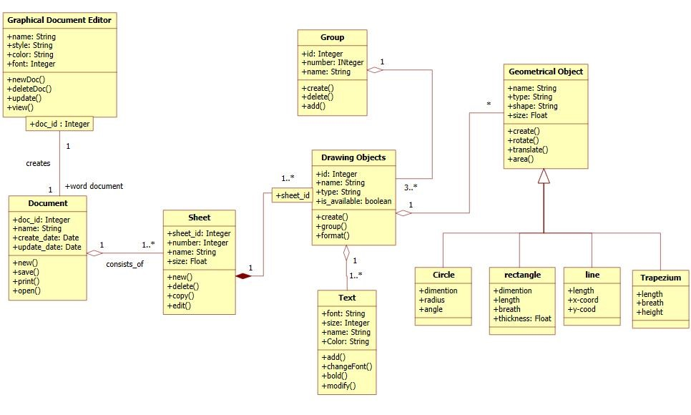

Fig 7.1

The graphical editor has documents consisting of several sheets. Each sheet contains drawing objects, including text, geometrical objects and groups. A group is simply a set of drawing objects. A geometrical object includes circle, ellipse, rectangles, lines and squares.

### 7.4 State Diagrams

**7.4.1 Simple State Diagram 7.4.2 Advanced State Diagram**

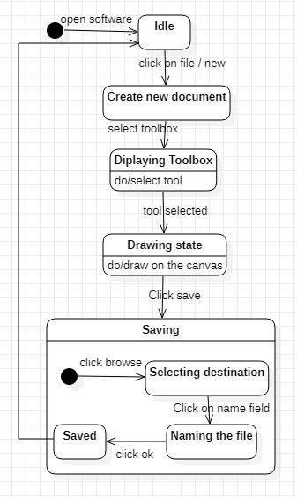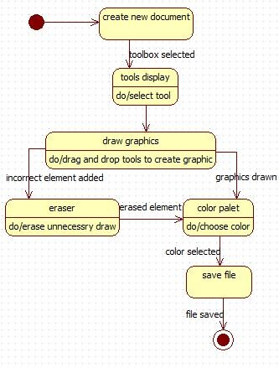

Fig

7.2

Fig 7.3

The simple state diagram and advanced state diagram gives the states involved in making and saving a graphic file.first the user selects a new document and draws graphics. If there is a mistake he can erase and select a color from the color palet. He can then save the file created.

The advanced state diagram had a composite state called saving where the user can save the file in their desired location.